

**Tribhuvan University**

**Faculty of Humanities and Social Sciences**

**PHARMACY MANAGEMENT**

**A PROJECT REPORT**

**Submitted to**

**Department of Computer Application Divya Gyan College**

##### In partial fulfillment of the requirements for the Bachelors in Computer Application.

**Submitted by Kushal Tiwari (S.N. 7511775)**

**May, 2022**

**Under the Supervision of Mr. Shailendra Basnet**



**Tribhuvan University**

**Faculty of Humanities and Social Sciences**

**Divya Gyan College**

**SUPERVISOR’S RECOMMENDATION**

I hereby recommend that this project prepared under my supervision by Kushal Tiwari (TU Symbol No. 7511775) entitled “**PHARMACY MANAGEMENT SYSTEM”** in partial fulfillment of the requirements for the degree of Bachelor of Computer Application is recommended for the final evaluation.



**SUPERVISOR**

Shailendra Basnet Project Coordinator Department of IT

Divya Gyan College Putalisadak, Kathmandu

https://lh3.googleusercontent.com/LYRMwuejRlugoGMq8AkiuzHT_BRyeSUjAU-MKkX8hVTNPvKKIJ6fPuZmV6fLX_JeIoKlUvEpfioWJXyrnvYYLdYpZa8phntKDS4OBOiQjrLDOrpBpPA08VUu0frTFDIOwhlq3O12

**Tribhuvan University**

**Faculty of Humanities and Social Sciences Divya Gyan College**

#### LETTER OF APPROVAL

This is to certify that this project prepared by Kushal Tiwari (TU Symbol No. 189391035) entitled “**PHARMACY MANAGEMENT SYSTEM”** in partial fulfillment of the requirements for the degree of Bachelor in Computer Application has been evaluated. In our opinion, it is satisfactory in the scope and quality as a project for the required degree.

|  |  |
| --- | --- |
| **Signature of Supervisor**  Mr. Shailendra Basnet Project Coordinator Department of IT  Divya Gyan College | **Signature of HOD/ Coordinator**  Mrs. Annu Khanna Head of Department Department of IT  Divya Gyan College |
| **Signature of Internal Examiner** | **Signature of External Examiner** |

**ABSTRACT**

A pharmacy management software is any system used in a pharmacy that helps automate the pharmacy workflow. This includes such tasks as reviewing physician orders and preparing medications, controlling the inventory and making drug orders, handling billing and insurance, providing counseling, identifying incompatibilities, and more all while following legal protocols and compliances. These are just the traditional functions that can be automated. Many more features can give the pharmacy a competitive edge by providing better customer experience and attract patients with more personalized and engaging service. The pharmacist has to order drugs to replenish the already diminishing stock. In addition, ordering of drugs is being carried out manually. Drugs are not supposed to be used after they have expired. The set-up of this pharmacy management system will ensure availability of sufficient quantity of drugs and consumable materials for the patient. This project work will prompt the pharmacist about drugs that are close to expiry, preventing those drugs from being sold and also providing solution to the earlier stated problems. Pharmacy management system helps in storing the daily transactions of medicines.

**Keywords**: *order, drugs, customer*

**Technology used:** *HTML, CSS, Javascript, PHP, MySql*

**Methodology:** *Waterfall model*

**ACKNOWLEDGEMENT**

The project “Pharmacy Management System” would not have been possible without the joint efforts of many individuals. I would like to express our sincere thanks to all who are involved in this project.

I would like to express our deep sense of gratitude to all those who devoted their energy, resources and time to the success of this project. My warm respect goes to the Divya Gyan College department, project supervisor **Mr.** **Shailendra Basnet** andprogram co-ordinator **Mrs. Annu Khanna** forall thevaluable suggestions for the project to reach this level and for providing all the guidelines, reference books and workspace for the development of our project.

At the end, I would like to express our sincere thanks to all our friends who have directly or indirectly helped me in this project.

Kushal Tiwari (Symbol no: 7511775)

**TABLE OF CONTENTS**

SUPERVISIOR’S i

LETTER OF APPROVAL ii

ABSTRACT iii

ACKNOWLEDGEMENT iv

TABLE OF CONTENT v

LIST OF ABBREVIATIONS vii

LIST OF FIGURES viii

LIST OF TABLES ix

Chapter 1: Introduction 1

* 1. Introduction 1
  2. Problem Statement 1
  3. Objectives 1
  4. Scope and Limitation 1
  5. Development Methodology 2
  6. Report Organization 2

Chapter 2: Background Study and Literature Review 3

* 1. Background Study 3
  2. Literature Review 3
  3. Existing System Review 4

Chapter 3: System Analysis and Design 5

* 1. System Analysis 5
     1. Requirement Analysis 5
     2. Feasibility Analysis 18
     3. Data Modelling (ER-Diagram) 19
     4. Process Modelling (DFD) 21
  2. System Design 23
     1. Architectural Design 23
     2. Database Schema Design 24

Chapter 4: Implementation and Testing 27

* 1. Implementation 27
     1. Tools 27
     2. Implementation Details of Modules 27
  2. Testing 30
     1. Test Cases for Unit Testing 31

Chapter 5: Conclusion and Future Recommendations 38

* 1. Outcome 38
  2. Conclusion 38

REFERENCES 39

**APPENDICES**

**LIST OF ABBREVIATIONS**

|  |  |
| --- | --- |
| CSS: | Cascading Style Sheet |
| ER: | Entity-Relationship |
| PMS: | Pharmacy Management System |
| HTML: | Hypertext Markup Language |
| IDE: | Integrated Development Environment |
| PHP: | Hypertext Preprocessor |
| SQL: | Structured Query Language |

**LIST OF FIGURES**

Figure 3.1: Use Case Diagram of PMS 6

Figure 3.2: Use Case Diagram for Login Module 7

Figure 3.2: Use Case Diagram for Manage Medicine Module 9

Figure 3.2: Use Case Diagram for Manage Customer Module 11

Figure 3.2: Use Case Diagram for Manage Stock Module 13

Figure 3.2: Use Case Diagram for Manage Invoice Module 15

Figure 3.3: ER-Diagram of PMS 20

Figure 3.4: Context Diagram of PMS 21

Figure 3.5: Level 1 DFD of PMS 22

Figure 3.6: 3-Tier Architecture 23

Figure 3.7: Database Schema Design 24

Figure 4.1: Modules Implementation 28

**LIST OF TABLES**

Table 3.1: Use Case of Login Module 6

Table 3.1: Use Case of Login Module 6

Table 3.1: Use Case of Login Module 6

Table 3.1: Use Case of Login Module 6

Table 3.1: Use Case of Login Module 6

Table 3.2: Data Dictionary 16

Table 3.3: Data Dictionary of customer 16

Table 3.4: Data Dictionary of invoice 16

Table 3.5: Data Dictionary of medicine 17

Table 4.1: Modules Implementation 19

Table 4.2: Test Case for Login 22

Table 4.3: Test Case for adding new customer 24

Table 4.4: Test Case for adding new medicine 26

## Chapter 1: Introduction

### Introduction

The Pharmacy Management System is a project developed to automate medical stores’ activities and improve their productivity. This helps pharmacies organize, manage, and secure drug information efficiently. Its’ features aids in the resolution of challenges with manual pharmacy management. A Pharmacy Management System can also help you keep track of your drug supplies. Prescriptions are proper and supplied in precise amounts using Pharmacy Management software. It oversees and manages the pharmacy team to preserve strong working relationships and outcomes. This can also improve quality and customer satisfaction ratings, as well as keep medicines from going bad.

### Problem Statement

Pharmacists can use the Pharmacy Management System program to help them methodically manage their pharmacies. When a medicine’s name is input, the Pharmacy Management System can help by providing details about the medicine. A computer displays information about the medicine, such as its dosage and expiration date. In large medical stores, manually handling the specifics of all the drugs becomes very tough. We can keep track of all the medicines by using this pharmacy management system.

### Objectives

The pharmacy management system is simply made to solve the day-to-day problems in a pharmacy. The main objective of this system is to maintain the information of medicines, customers and transactions. This system allows the administrator to record medicine information, view customer information, manage invoices and so on.

The various objectives of developing Pharmacy Management System are:

* + - To develop a web-based application to automate the working procedures.
    - To digitize the system making it paperless operations.
    - To provide a secured system to store and retrieve data.

### Scope and Limitation

Pharmacy do many transactions daily such as buying medicines from vendors as well as customers which requires a comprehensive report as well as information about the medicine distributors. This has been our main limitation in this project.

Some limitations are:

* + - Full report generation feature is not provided in order to store various exported reports.
    - Vendor information is not taken into account while recording new medicines.

### Report Organization

Chapter 1: Introduction

It describes the pharmacy management system and its objectives in present context.

Chapter 2: Background Study and Literature Review

It studies about the limitations of the manual system of present pharmacy system and need of online pharmacy management system.

Chapter 3: System Analysis and Design

It describes the functional and non-functional requirements along with feasibility analysis of the pharmacy managements system.

Chapter 4: Implementation and Testing

It describes about the tools used in this system and the testing that are done.

Chapter 5: Conclusion and Future Recommendations

It describes about the outcome of this system as well as the future recommendations for the pharmacy management system.

**Chapter 2: Background Study & Literature**

### 2.1. Background Study

Pharmacy management system is a management system that is designed to improve accuracy and to enhance safety and efficiency in the pharmaceutical store. This program can be used in any pharmaceutical shops having a database to maintain. It is a computer based system which helps the pharmacist to improve inventory management, cost, medicine safety, etc. The software used can generate reports, as per the user’s requirements. Using the pharmacy management system user is also able to generate report within a specified period of time. The system allows the user to enter a manufacturing and expiry date for a particular product or drug during opening stock and sales transaction. The software can print invoices, bills, receipts, etc. It can also maintain the record of supplies sent in by the supplier. The system will also give report showing the list of products expiry after a specified date before the product eventually expires. The system services and goals are established by consultation movement out of the pharmacy for a certain period. Pharmacy managements system is robust, integrated technology. This pharmacy management system is user friendly.

### 2.2. Literature Review

At present, manual system is being utilized in the pharmacy. It requires the pharmacist to manually monitor each drug that is available in the pharmacy. Pharmacy management has kept paper record in filing cabinets. Managing a very large pharmacy with records on papers will be tedious and difficult to keep track of inventories with regards to the drugs in the store, expiry date, quantity of drugs available based on the categories and their functions. This implies that these services will be manually completed by the pharmacist. This usually leads to mistakes as the workload of the pharmacist increases. This system also ensures that there exists a level of restricted access based on functionality and role. This system also provides optimal drug inventory management by monitoring the drug movement in the pharmacy. Significant amount of time is allocated for writing the order as the pharmacist needs to go through the stock balance and make rough estimate of the amount to order based on Figures. The system will not be able to handle drug prescription, drug to drug interaction.

### 2.3. Existing System Review

The preliminary findings of the implementation process of a pharmacy management system at a local Saudi hospital. Meeting documents, key informant interviews, and experience of the researcher were part of the data collection sources used in the study. A thematic analysis of the data was conducted. Preliminary findings show that the implementation process of the pharmacy inventory management system needs the involvement and support of senior management and experienced technical expertise. Future research will focus on investigating the impacts of the pharmacy inventory management system on workflow and medication errors. The similarities of the proposed system to the Pharmacy Inventory Management System are almost the same in terms of Automated System, Connectivity, Platforms (PC or Android), and Point of Sale.

.

## Chapter 3: System Analysis and Design

### System Analysis

It is a process of collecting and interpreting facts, identifying the problems, and decomposition of a system into its components of pharmacy management system. It is conducted for the purpose of studying a system or its parts in order to identify its objectives. It is a problem-solving technique that improves the system and ensures that all the components of the system work efficiently to accomplish their purpose.

#### Requirement Analysis

Requirements analysis is a process used to determine the needs and expectations of the pharmacy management system. It involves frequent communication to define expectations, resolve conflicts, and document all the key requirements.

* + - 1. **Functional Requirements:**

A functional requirement (FR) is a description of the service that the pharmacy management system must offer. It is a statement of services the system should provide, how the system should react to particular inputs and how the system should behave in particular situations.

* + - 1. **Use case diagrams:**

Use case diagram are considered for high level requirement analysis of pharmacy management. When the requirements of a system are analyzed, the functionalities are captured in use case. The purpose of use case diagram is to capture the dynamic aspect of a system. It is used to gather the requirements of a system including internal and external influences. It is used to get an outside view of a system [1].

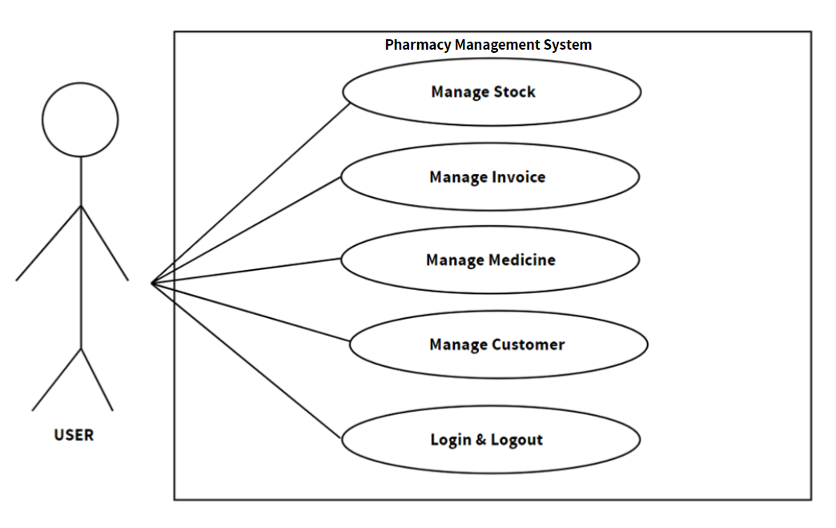

**Figure 3.1: Use Case Diagram of Pharmacy Management System**

Requirement:

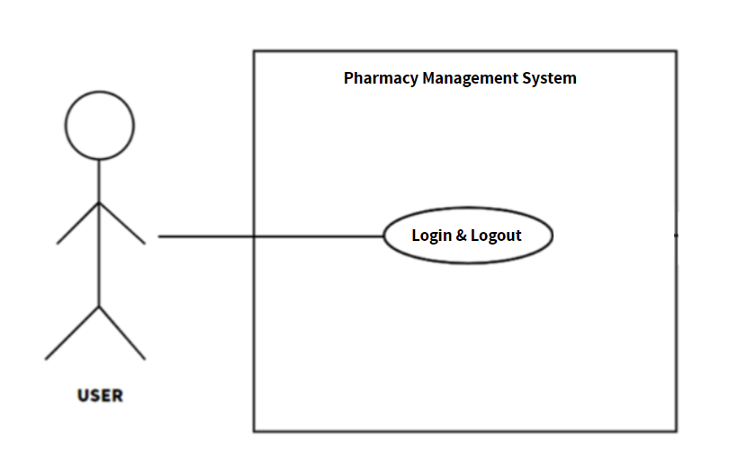

**Figure 3.2: Use Case Diagram for “Login & Logout Module”**

**Table 3.1: Use Case of Login & Logout Module**

|  |  |
| --- | --- |
| Use Case ID | UC-001 |
| Use Case Name | Login & Logout |
| Actors | User, Pharmacy Management System |
| Brief Description | It shall provide all the users to enter their username and password to enter into the system if they are registered users. It shall provide sign up feature if the user is not registered yet. It shall also provide all the users to logout of the system. |
| Preconditions | The system is operational.  The user must be a registered user.  The user has a unique username and password. |
| Post Conditions | User enters into the system.  User performs the required actions.  User exits out of the system. |
| Failure Scenarios | Fail due to authentication failure.  Fail due to invalid username and password.  Fail due to inadequate critical resources. Fail due to non-responding  pharmacy system. |

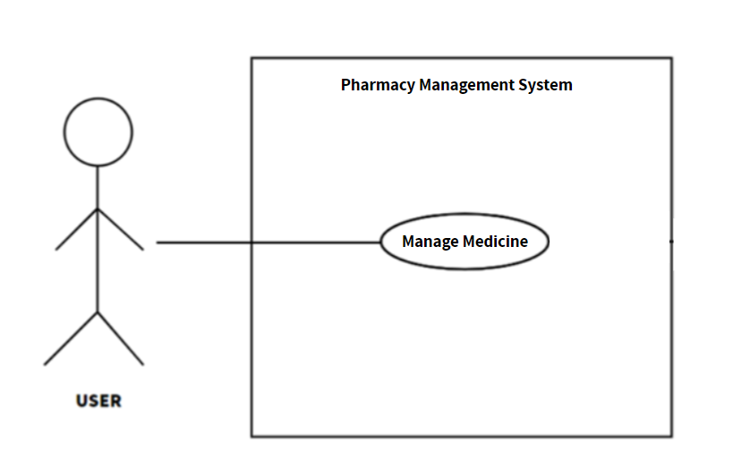

**Figure 3.2: Use Case Diagram for “Manage Medicine Module”**

**Table 3.1: Use Case of Manage Medicine Module**

|  |  |
| --- | --- |
| Use Case ID | UC-002 |
| Use Case Name | Manage Medicine |
| Actors | User, Pharmacy Management System |
| Brief Description | It shall provide users with the facility to add new medicine, view existing medicine details, edit existing medicine details and remove existing medicine from the list. |
| Preconditions | The system is operational.  The user is logged into the system.  The stock for the medicine is available |
| Post Conditions | User adds a new medicine.  User edits an existing medicine.  User removes a medicine. |
| Failure Scenarios | User adds a medicine for which the stock is not available.  Failed due to critical resources missing. |

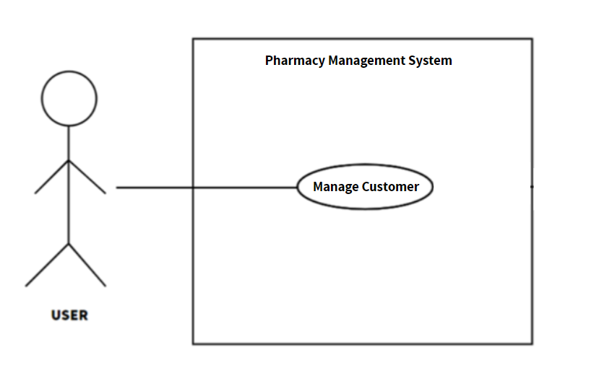

**Figure 3.2: Use Case Diagram for “Manage Customer Module”**

**Table 3.1: Use Case of Manage Customer Module**

|  |  |
| --- | --- |
| Use Case ID | UC-003 |
| Use Case Name | Manage Customer |
| Actors | User, Pharmacy Management System |
| Brief Description | It shall provide users with the facility to add new customer, view existing customer details, edit existing customer details and remove existing customer from the list. |
| Preconditions | The system is operational.  The user is logged into the system. |
| Post Conditions | User adds a new customer.  User edits an existing customer.  User removes a customer. |

|  |  |
| --- | --- |
| Failure Scenarios | Failed due to invalid customer information.  Failed due to critical resources missing.  Failed due to non-responding pharmacy system. |

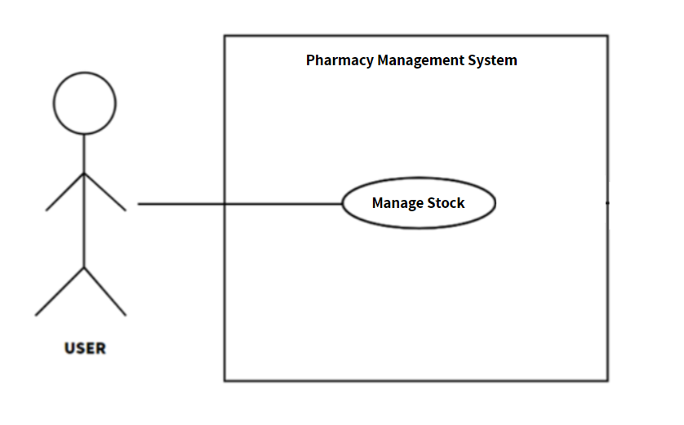

**Figure 3.2: Use Case Diagram for “Manage Stock Module”**

**Table 3.1: Use Case of Manage Stock Module**

|  |  |
| --- | --- |
| Use Case ID | UC-004 |
| Use Case Name | Manage Customer |
| Actors | User, Pharmacy Management System |
| Brief Description | It shall provide users with the facility to add new stock, view existing stock details, edit existing stock details and remove existing stock from the list. |
| Preconditions | The system is operational.  The user is logged into the system. |
| Post Conditions | User adds a new stock.  User edits an existing stock information.  User removes a stock from the list. |

|  |  |
| --- | --- |
| Failure Scenarios | Failed due to invalid stock information.  Failed due to critical resources missing.  Failed due to non-responding pharmacy system. |

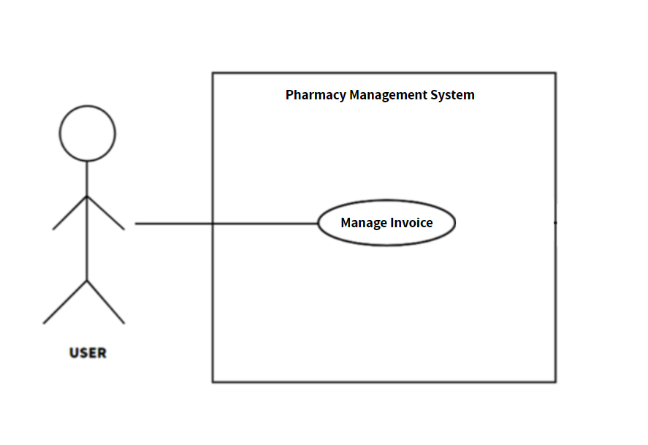

**Figure 3.2: Use Case Diagram for “Manage Invoice Module”**

**Table 3.1: Use Case of Manage Invoice Module**

|  |  |
| --- | --- |
| Use Case ID | UC-005 |
| Use Case Name | Manage Invoice |
| Actors | User, Pharmacy Management System |
| Brief Description | It shall provide users with the facility to add new invoice, view existing invoice details, edit existing invoice details and remove existing invoice from the list. |
| Preconditions | The system is operational.  The user is logged into the system. |
| Post Conditions | User adds a new invoice.  User edits an existing invoice.  User removes an invoice. |

|  |  |
| --- | --- |
| Failure Scenarios | Failed due to invalid invoice information.  Failed due to critical resources missing.  Failed due to non-responding pharmacy system. |

* + - 1. **Non-Functional Requirements:**

**Performance**

The performance of the pharmacy management will highly depend on the performance of the hardware and software components of the installed devices. Responses to view information shall take no longer than 5 seconds to appear on the screen.

**Safety Requirements**

In case of database failures, the pharmacy management system shall provide database backup after a set amount of time for safety purpose. There are several users in pharmacy management system so every user shall log in using their username and password to use any features.

**Security Requirements**

The system shall provide access to the only authorized users and also provide database security. The admin of pharmacy management system shall access all the information’s.

**Software Quality Attributes**

Availability: The system shall be available 24 hours a day.

Correctness: It shall reach to the correct destination as per the reservation made by customer.

Maintainability: The admin shall maintain correct record of the rooms and the customers.

Efficiency: It shall utilize processor capacity, disk space and memory efficiently.

Usability: It shall be easy to use so that the user can interact with the system easily to do the needed work.

Understandability: It shall be understandable easily.

Testability: It shall be easy to test and find defects.

Flexibility: It shall be able to add new features to the system and handle them conveniently.

#### Feasibility Analysis

The objective behind the feasibility study is to create the reasons for developing the pharmacy management system that is acceptable to users and flexible to change. A feasibility study is an analysis that takes all of a project's relevant factors into account including economic, technical, legal, and scheduling considerations.

* + - 1. **Technical Feasibility:**

In this, one has to test whether the system can be developed using existing technology or not. We have used HTML, CSS as front-end and PHP and SQL server as backend. The system is more practical and mature method of pharmacy management system.

* + - 1. **Operational Feasibility:**

The main purpose of this program is to develop a web-based application which facilitates online management of pharmaceutical transactions through internet. This system reduces a lot of human effort and errors as well. Therefore, this project is operationally feasible.

* + - 1. **Economic Feasibility:**

In existing system, the pharmacy had to maintain many registers/books which are a costly affair. This can be reduced by keeping data in the digital format that is reliable and cheaper. The development cost for system satisfies the organization.

* + - 1. **Schedule Feasibility:**

This criteria model is parallel goes with the scheduled time. Ability to finish the project on time is measure under this model. The pharmacy management system has been completed on the scheduled time where more priority is given to customer satisfaction.

* + 1. **Data Modeling (ER-Diagram)**

Data modelling is the process of creating a data model for the data to be stored in a database. It is also helpful to identify missing and redundant data. Data model structure helps to define the relational tables (primary and foreign keys and stored procedure).

**ER Diagram:**

An entity-relationship diagram is a visual presentation of entities and relationships that is often used in the semi-structures or unstructured data in database and information system.

* Entities: specify distinct real-world items.
* Properties/Attributes: specify properties of an entity and relationships.
* Relationships: connect entities and represent meaningful dependencies between them.

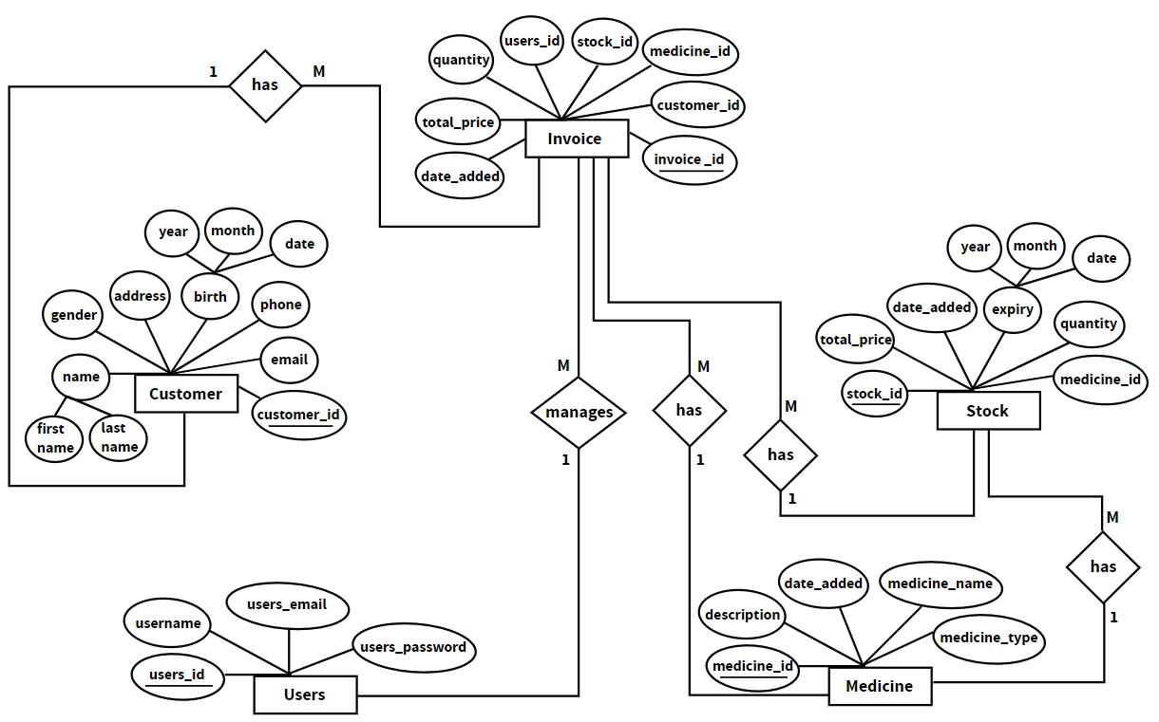

**Figure 3.7: ER Diagram of Pharmacy Management System**

* + 1. **Process Modeling (DFD)**

A common form of a process model is a DFD. Like a flow chat, individual steps of the process are drawn out so there is an end-to-end overview of the tasks in the process within the context of the business environment.

**Dataflow Diagram (DFD):**

A data flow diagram is a way of representing a flow of a data of pharmacy management system. Pharmacy management system’s Data Flow Diagram is often used as a preliminary step to create an overview of the system without going into great detail, which can later be elaborated [2].

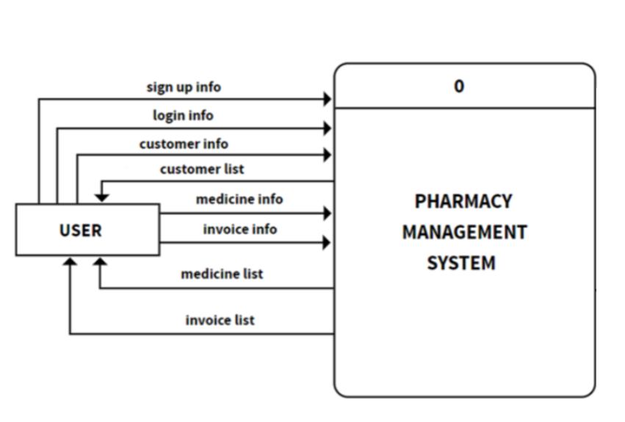

**Figure 3.8: Context Diagram of Pharmacy Management System**

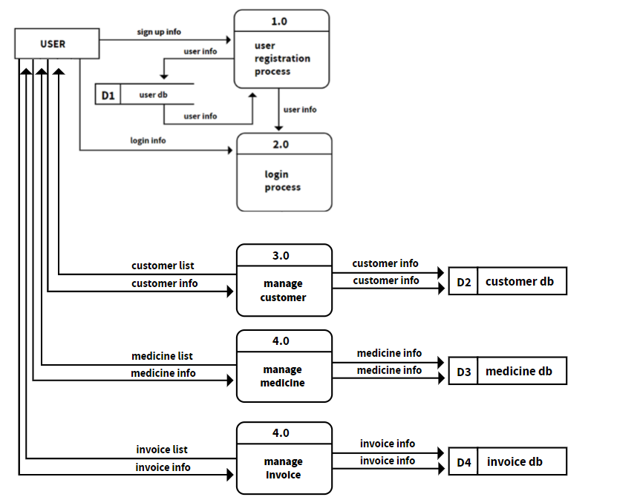

**Figure 3.9: Level-1 DFD of Pharmacy Management System**

### System Design

#### Architectural Design

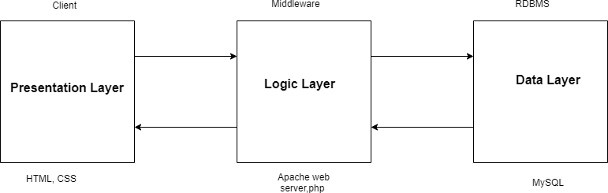

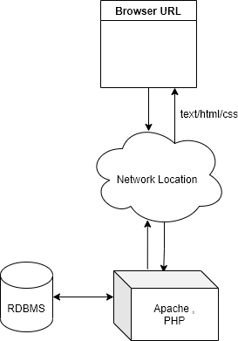

**Figure 3.10: 3-tier Architecture [3]**

There are different types of architecture i.e. one tier architecture, two tier architecture and three tier architecture. The architectural design of pharmacy management system is based on three tier architecture. There are three component they are:

1. Presentation layer
2. Logical layer
3. Database layer

Client server is server to run our website on the webpage. Web server is the part where all coding practices occurs like php. And as a database we have used MySQL to store all the information of the website. Pharmacy system has three components, the client, server and the network connection in between. Server-Client architecture defines a system network in which a centralized server is used to provide resources and services to many clients using remote devices. In this architecture the server is responsible for data storage, data access logic and application logic. The client computers serve as presentation logic and also share responsibility with the server on the application logic.

#### Database Schema Design

Database schema design is a strategy for constructing a framework for data management. It is an abstract design that represent the storage of our data in a database. It describes both the organization of data and the relationships between tables in a gives database. It is like blueprint for massive amount of data.

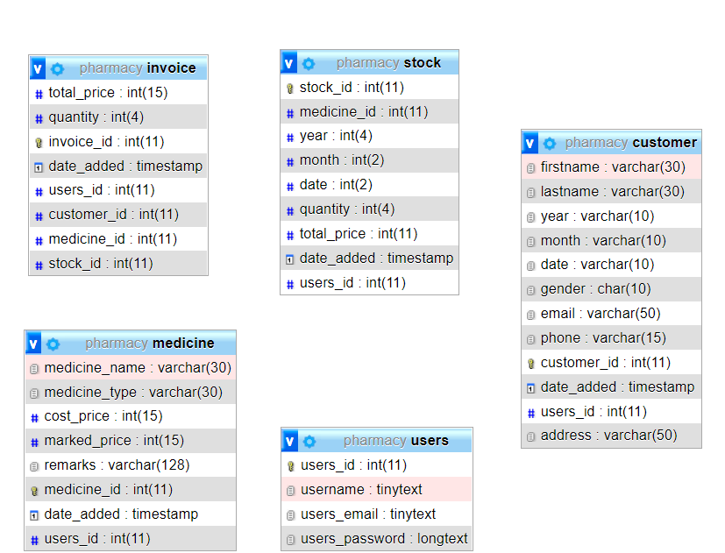

**Figure 3.11: Relational Model of Pharmacy Management System**

**Table 3.5: Data Dictionary of users**

|  |  |  |
| --- | --- | --- |
| **Field Name** | **Datatype** | **Constraint** |
| users_id | int(11) | Primary key |
| username | tinytext | NOT NULL |
| users_email | tinytext | NOT NULL |
| users_password | longtext | NOT NULL |

**Table 3.6: Data Dictionary of customer**

|  |  |  |
| --- | --- | --- |
| **Field Name** | **Datatype** | **Constraint** |
| customer_id | int(11) | Primary key |
| firstname | varchar (30) | NOT NULL |
| lastname | varchar (30) | NOT NULL |
| year | varchar (10) | NOT NULL |
| month | varchar (10) | NOT NULL |
| date | varchar (10) | NOT NULL |
| gender | char(10) | NOT NULL |
| address | Varchar(50) | NOT NULL |
| email | varchar(50) | NOT NULL |
| phone | varchar(15) | NOT NULL |
| date_added | timestamp | NOT NULL |

**Table 3.7: Data Dictionary of invoice**

|  |  |  |
| --- | --- | --- |
| **Field Name** | **Datatype** | **Constraint** |
| invoice_id | int(11) | Primary key |
| customer_id | int(11) | Foreign Key |
| medicine_id | int(11) | Foreign Key |
| total_price | int(15) | NOT NULL |
| quantity | int(4) | NOT NULL |
| date_added | timestamp | NOT NULL |
| users_id | int(11) | Foreign_key |
| stock_id | Int(11) | Foreign key |

**Table 3.8: Data Dictionary of medicine**

|  |  |  |
| --- | --- | --- |
| **Field Name** | **Datatype** | **Constraint** |
| medicine_id | int(11) | Primary key |
| medicine_name | varchar (30) | NOT NULL |
| medicine_type | varchar (30) | NOT NULL |
| description | varchar(128) | NOT NULL |
| date_added | timestamp | NOT NULL |
| users_id | int(11) | Foreign key |

**Table 3.8: Data Dictionary of stock**

|  |  |  |
| --- | --- | --- |
| **Field Name** | **Datatype** | **Constraint** |
| stock_id | int(11) | Primary key |
| medicine_id | int(11) | Foreign Key |
| year | int(4) | NOT NULL |
| month | int(2) | NOT NULL |
| date | int(2) | NOT NULL |
| quantity | int(4) | NOT NULL |
| date_added | timestamp | NOT NULL |
| total_price | int(11) | NOT NULL |

## Chapter 4: Implementation and Testing

### Implementation

In this stage, physical system specifications are converted into a working and reliable solution. This is where the system is developed. On receiving the system design documents, the work is divided in modules/units and actual coding is started. It is followed by testing. Several tools are used in this phase of the software development.

* + 1. **Tools Used:**
       - PHP: Server-side scripting language designed for web development.
       - Sublime Text: IDE used for HTML, CSS and JavaScript.
       - MySQL: Open-source relational database management system
       - Apache: Web server
       - Adobe XD: UI design
       - Front-end: HTML, CSS
       - Backend: PHP, JavaScript

#### Implementation Details of Modules

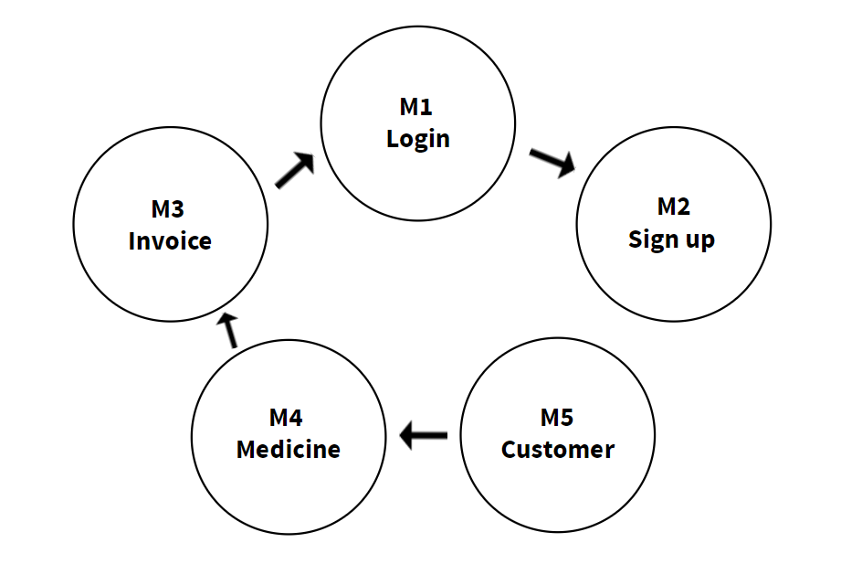

**Figure 4.1: Modules Implementation**

**Table 4.1: Module Implementation**

|  |  |  |  |
| --- | --- | --- | --- |
| **Code** | **Module name** | **Arguments** | **Return Type** |
| M1 | Login | email: string password: string | void |
| M2 | Sign up | firstname: string lastname: string email: string password: string | void |
| M3 | Invoice | customer_  name: string medicine_  name: string  price_per_  unit: int  quantity: int  users_id: int | Void |
| M5 | Medicine | medicine_  name: string  medicine_  type: string  year: int  month: int  date: int  cost_price: int  marked_  price: int  quantity: int  remarks: string | void |
| M4 | Customer | firstname:  string  lastname: string  year: int  month: int  date: int  gender: string  municipality: string  district: string  ward: int  email: string  phone: int | void |

### Testing

#### Test Cases for Unit testing

Unit testing refers to the testing of every small modular components of the system, keeping them isolated from other modules. In this test phase, the errors were corrected and modifications made as and where required. Steps followed in performing unit tests:

* Conduct the code execution tests
* Identify and resolve any errors
* Determine that the test is complete.

**Table 4.2: Test case for Login**

|  |  |  |  |  |  |  |  |
| --- | --- | --- | --- | --- | --- | --- | --- |
| Project Name: Pharmacy Management System | | | | | | | |
| Test Case | | | | | | | |
| Test Case ID: TC_001 | | | | Test Designed by: Kushal Tiwari | | | |
| Test Priority (Low/Medium/High): Medium | | | | Test Designed date: 06-16-2022 | | | |
| Module Name: Login | | | | Test Executed by: Kushal Tiwari | | | |
| Test Title: Verify login | | | | Test Execution date: 06-16-2022 | | | |
| Description: Test the login functionality of pharmacy management system. | | | | | | | |
| Pre-conditions: User is already registered in the system. | | | | | | | |
| Dependencies: | | | | | | | |
| Step | Test Steps | Test Data | Expected  Result | | Actual Result | Status(Pa  ss/Fail) | Note |
| 1 | Navigate to login page |  | login page should open | | As Expected i.e. User is navigate to login page of pharmacy management system. | Pass |  |
| 2 | Enter valid username and  password | Username=ABC Password=12345 | Verified credentials details are  entered | | As Excepted | Pass |  |
| 3 | Click on LOGIN  button | click | User should be able to login | | As Expected i.e. User is able to login in the  pharmacy management system. | Pass |  |
| Post-conditions:  User is validated with database and successfully login to pharmacy management system. | | | | | | | |

**Table 4.3: Test case for recording customer details**

|  |  |  |  |  |  |  |  |
| --- | --- | --- | --- | --- | --- | --- | --- |
| Project Name: Pharmacy Management System | | | | | | | |
| Test Case | | | | | | | |
| Test Case ID: TC_002 | | | | Test Designed by: Kushal Tiwari | | | |
| Test Priority (Low/Medium/High): Medium | | | | Test Designed date: 16-06-2022 | | | |
| Module Name: Customer | | | | Test Executed by: Kushal Tiwari | | | |
| Test Title: Add customer | | | | Test Execution date: 16-06-2022 | | | |
| Description: Test the pharmacy management system. | | | | | | | |
| Pre-conditions: User should login to pharmacy management system.  User has to provide all the necessary details and submit form. | | | | | | | |
| Dependencies: | | | | | | | |
| Step | Test Steps | Test Data | Expected  Result | | Actual Result | Status  (Pass/Fail) | Not  es |
| 1 | Navigate to customer dashboard |  | Customer dasboard should open | | As Expected  i.e. user is  navigated to the page | Pass |  |
| 2 | Click on add new customer button | Click | Customer input section should open | | As Expected  i.e. user is  redirected to customer input section | Pass |  |
| 3 | Provide own details | firstname = Kushal  lastname =  Tiwari  year = 2010  month = 03  date = 13  municipality = Budhanilkantha  district = Kathmandu  ward = 12  email =  kushaltiwari@gmail.com  phone = 9898989898 | Credential can be entered | | As Expected | Pass |  |

|  |  |  |  |  |  |  |
| --- | --- | --- | --- | --- | --- | --- |
| 4 | Click on submit  button | Click | Form should be submitted | As Expected. | Pass |  |
| Post-conditions:  User should provide customer information and submit it to the database.  The user session details are logged in to the database. | | | | | | |

**Table 4.3: Test case for recording medicine details**

|  |  |  |  |  |  |  |  |
| --- | --- | --- | --- | --- | --- | --- | --- |
| Project Name: Pharmacy Management System | | | | | | | |
| Test Case | | | | | | | |
| Test Case ID: TC_003 | | | | Test Designed by: Kushal Tiwari | | | |
| Test Priority (Low/Medium/High): Medium | | | | Test Designed date: 16-06-2022 | | | |
| Module Name: Medicine | | | | Test Executed by: Kushal Tiwari | | | |
| Test Title: Add medicine | | | | Test Execution date: 16-06-2022 | | | |
| Description: Test the pharmacy management system. | | | | | | | |
| Pre-conditions: User should login to pharmacy management system.  User has to provide all the necessary details and submit form. | | | | | | | |
| Dependencies: | | | | | | | |
| Step | Test Steps | Test Data | Expected  Result | | Actual Result | Status  (Pass/Fail) | Not  es |
| 1 | Navigate to medicine  dashboard |  | Medicine dasboard should open | | As Expected  i.e. user is  navigated to the page | Pass |  |
| 2 | Click on add new medicine button | Click | Medicine input section should open | | As Expected  i.e. user is  redirected to medicine input section | Pass |  |
| 3 | Provide own details | medicine_name =  paracetamol  medicine_type =  tablet  year = 2010  month = 03  date = 12  cost_price = 100  marked_price = 120  quantity = 1  remarks =  used for  fever and headaches | Credential can be entered | | As Expected | Pass |  |

|  |  |  |  |  |  |  |
| --- | --- | --- | --- | --- | --- | --- |
| 4 | Click on submit  button | Click | Form should be submitted | As Expected. | Pass |  |
| Post-conditions:  User should provide customer information and submit it to the database.  The user session details are logged in to the database. | | | | | | |

## Chapter 5: Conclusion and Future Recommendations

### Outcome

Pharmacy management system is actually a software which handle the essential data and save the data and actually about the database of a pharmacy and it's management.This software help in effectively management of the pharmaceutical store or shop.It provide the statistics about medicine or drugs which are in stocks which data can also be updated and edited.It works as per the requirement of the user and have options accordingly.It allow user to enter manufacturing as well as the expiry date of medicine placing in stock and for sales transaction.This software also have ability to print the bill and invoices etc.The record of suppliers supplies can also be saved in it.There are other function available too . The main purpose is effectively and easily handling of pharmacy data and it's management.

### Conclusion

Effective implementation of this software will take care of the basic requirements ofthe pharmacy management system because it is capable of providing easy andeffective storage of information related to activities happening in the stipulated area.With these, the objectives of the system design will be achieved.26

In order to allow for future expansion, the system has been designed in such a waythat will allow possible modification as it may deem necessary by the pharmacymanagement, whenever the idea arises.

# REFERENCES

* Online student activity management system: https://patents.google.com/patent/US20050015291A1/en?q=online &q=student&q=activity&q=managment&q=system&q=employe&clustered=true
* Worker and document management system: https://patents.google.com/patent/US20040267595A1/en?q=online &q=student&q=activity,information,details&q=managment&q=system&q=marks+&page=1&clustered=true
* Database design for online systems: https://patents.google.com/patent/US6470171B1/en?q=~patent%2f US20030044762A1&clustered=true
* Entity Relationship diagram: https://everything.explained.today/Entity%E2%80%93relationship_model
* A primer on databases and catalogs:

<https://www.usg.edu/galileo/skills/unit04/primer04_01.phtml>

# APPENDICES

**i. Home Page**



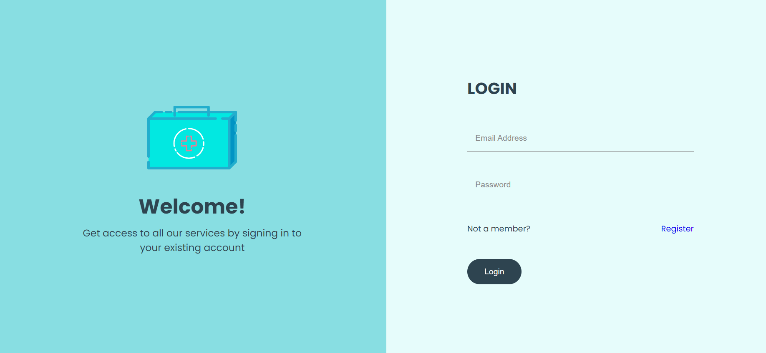**ii: Login Page**

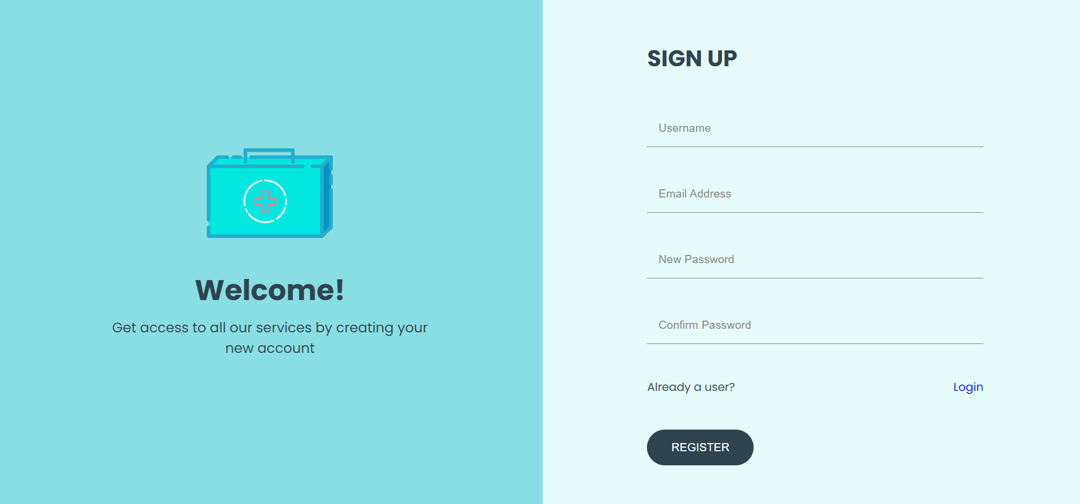**iii: Registration Page**

**iv: Admin dashboard**

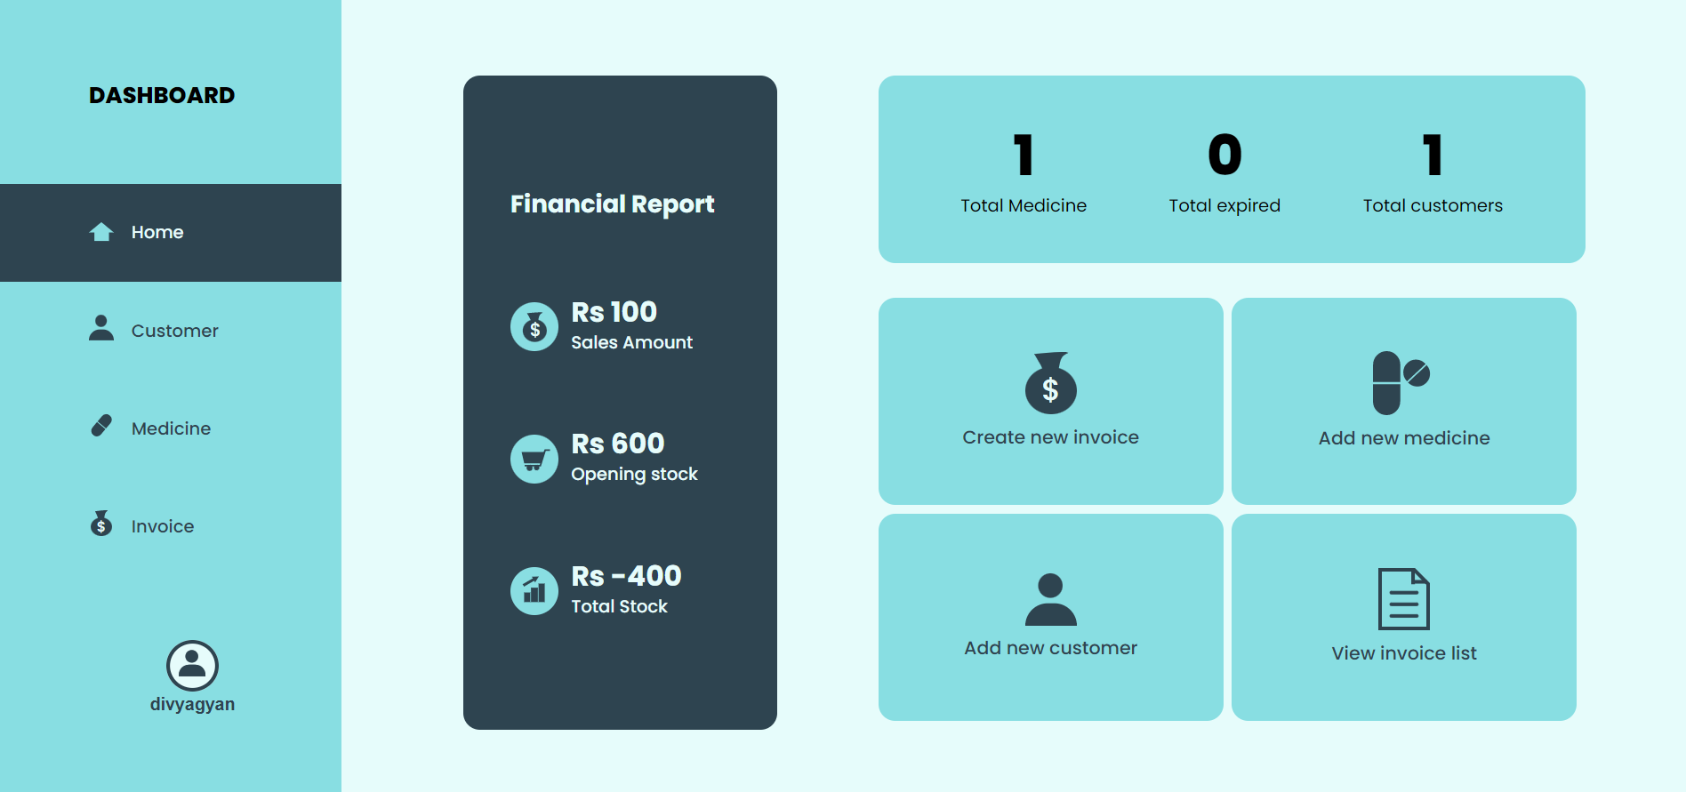

**v: Customer Dashboard**

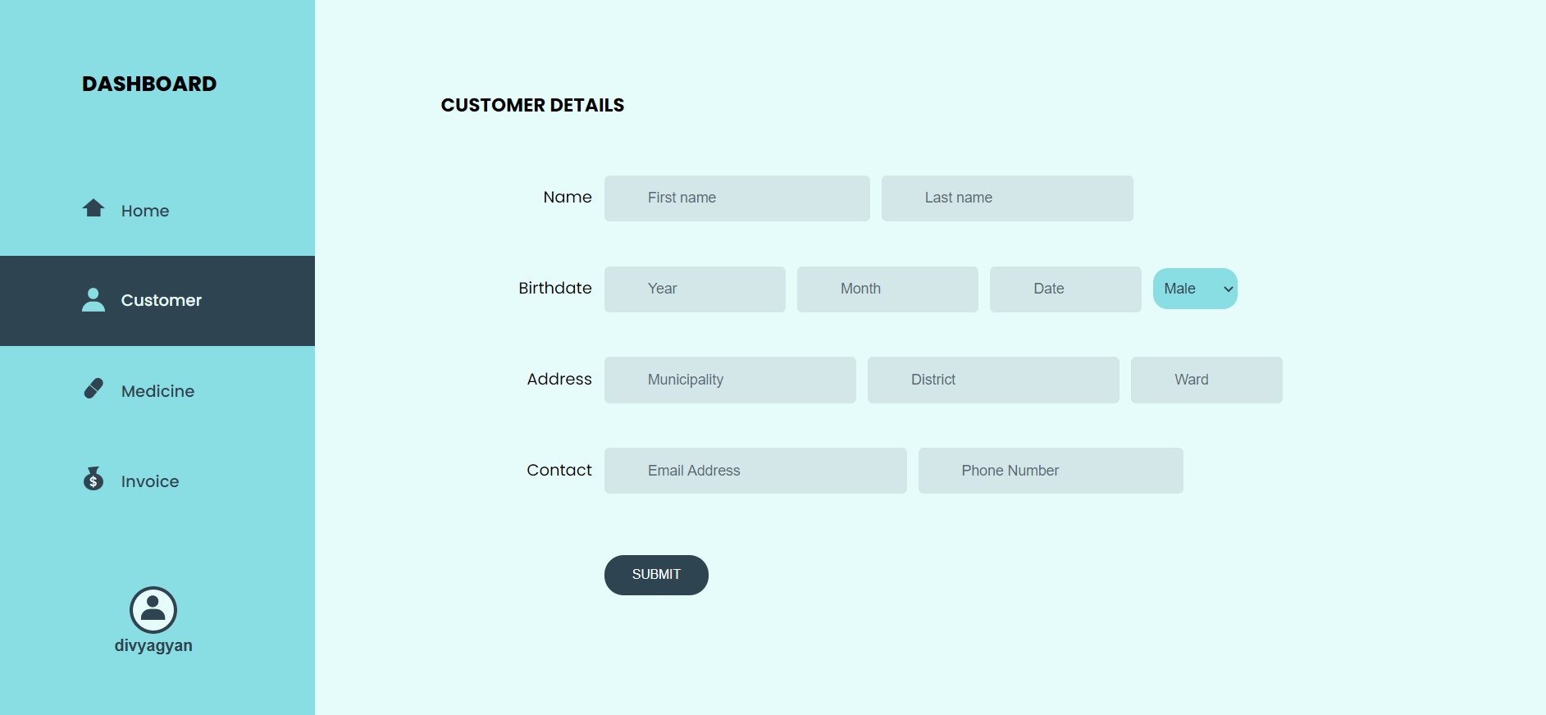

**vi: Medicine Dashboard**

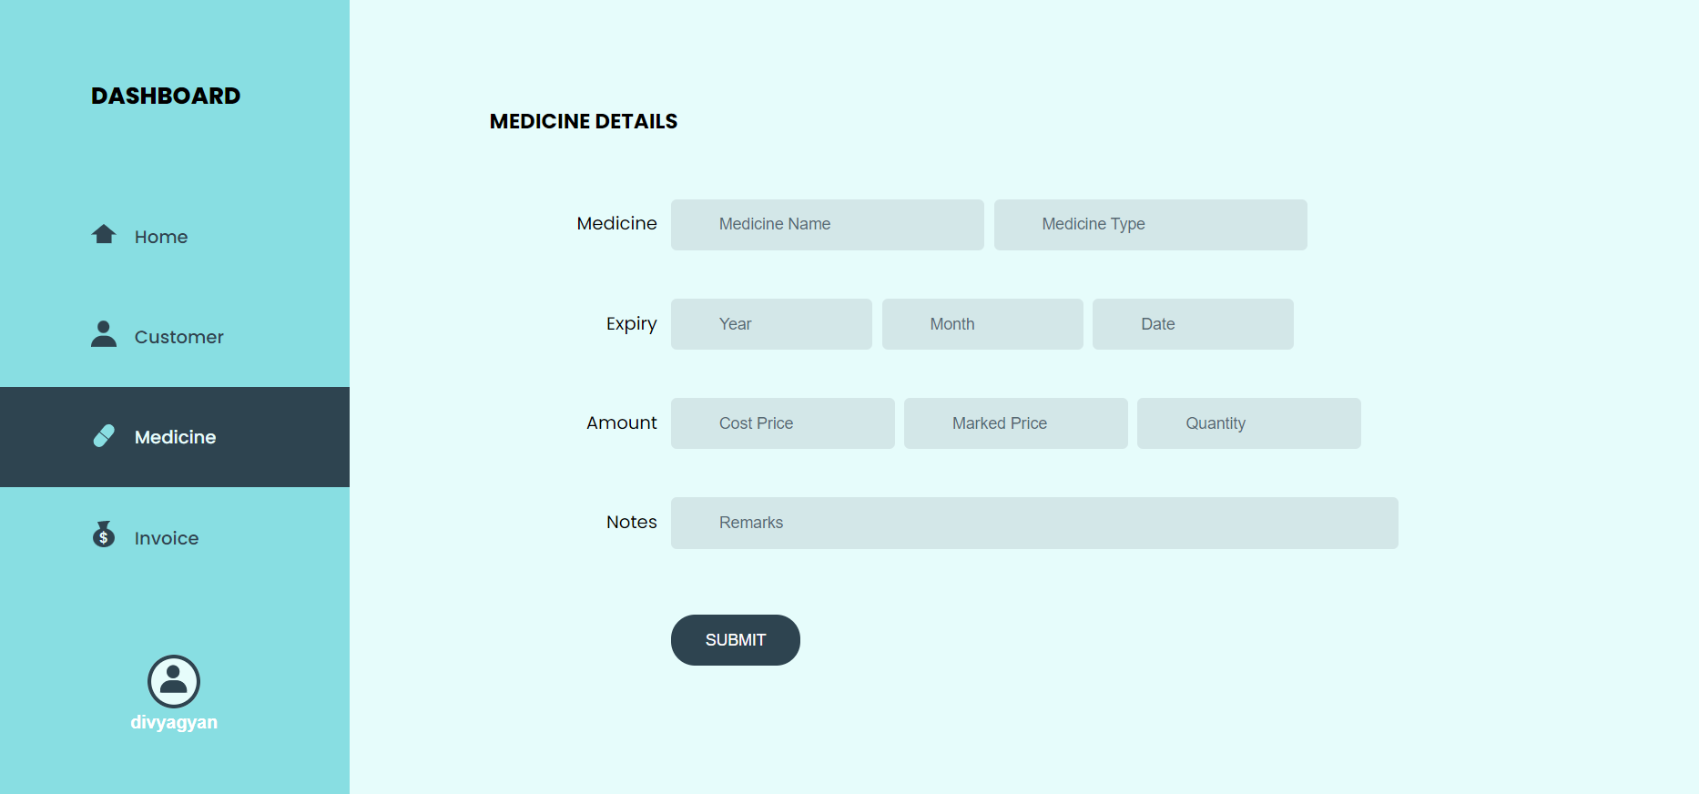

**vii: Invoice Dashboard**

